**Testing Document for Formal Programming Assignment (Python)**

In order to ensure that my program works correctly, I will execute a total of ten program tests because I have 10 different options. In all ten tests I will record the input, the expected output, the actual program output, and whether the program pass or failed the test.

*Note: Not all inputs/outputs will be recorded because of length of program, only the ones that affect the end of the program.*

**Test #1**

**Input:**

* Club = 1
* Average = 90
* Grade = 10
* Available = Yes
* Confirm Club = Yes
* Apply = No

**Expected Output:**

I expect the program to output:

* You have selected to join Robotics club!
* The club takes place on Monday.
* The club starts at 3pm.
* Mr. Johnson is the leader of the club.
* The club takes place in room 3315.
* You may be going to a robotics meet in Toronto.
* You may need to purchase a $5 shirt for participation in the club.
* The average needed for the club is 85%.
* The leader's room is 3315.
* Your average from last year was 90.0%.
* You are in grade 10.
* You have a high enough average to join Robotics!
* There are opportunities in your grade!
* You are available during Robotics!
* You have all the requirements to join this club.
* You have been reserved a spot in Robotics!
* Have a nice day!

**Actual Output:**

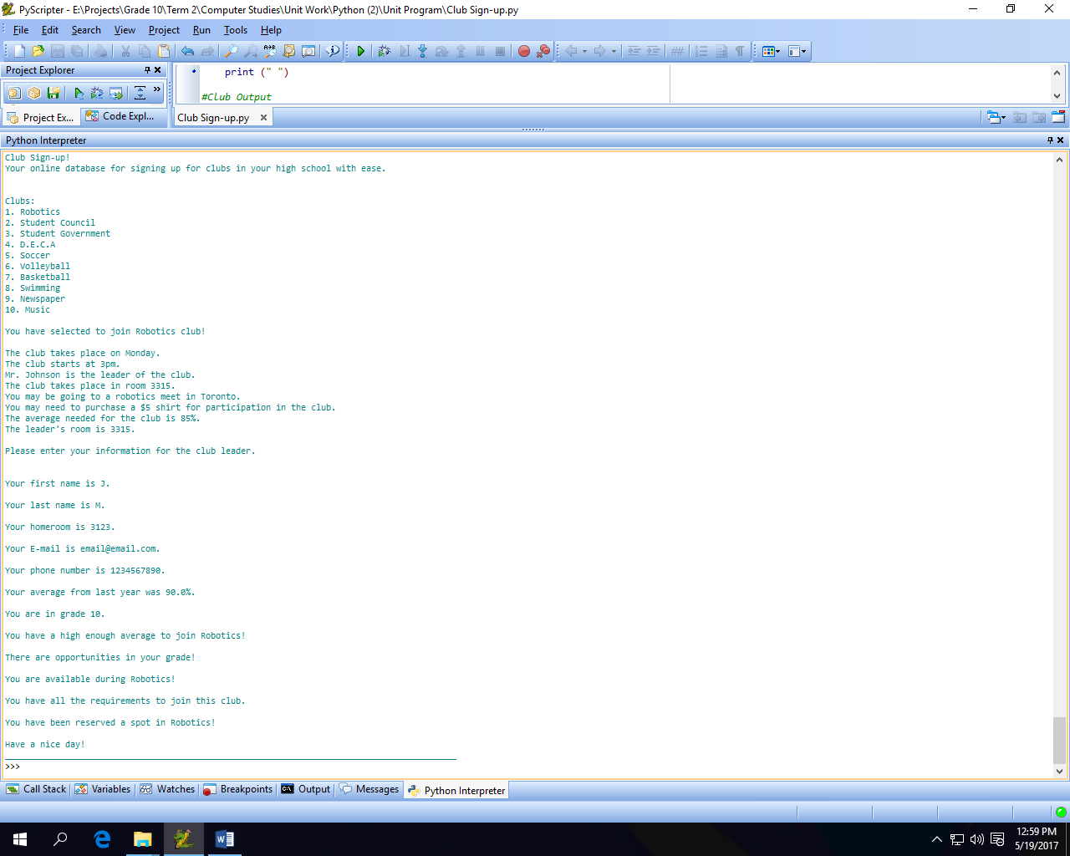

**Results:** Since the program didn’t crash and told the user whether they were eligible for the club they selected or not and gave them an option to retry, the program **passed** this test.

**Test #2**

**Input:**

* Club = 2
* Average = 100
* Grade = 9
* Available = Yes
* Confirm Club = No
* Apply = No

**Expected Output:**

I expect the program to output:

* You have selected to join Student Council!
* The club takes place on Tuesday.
* The club starts at 3pm.
* Mr. Fazel is the leader of the club.
* The club takes place in room 3221.
* You may be going to Wonderland for a conference.
* You may need to purchase a $5 shirt for participation in the club.
* The average needed for the club is 70%.
* The leader's room is 3222.
* Your average from last year was 100.0%.
* You are in grade 9.
* You have a high enough average to join Student Council!
* There are opportunities in your grade!
* You are available during Student Council!
* You have all the requirements to join this club.
* You have not been reserved a spot in Student Council.
* Have a nice day!

**Actual Output:**

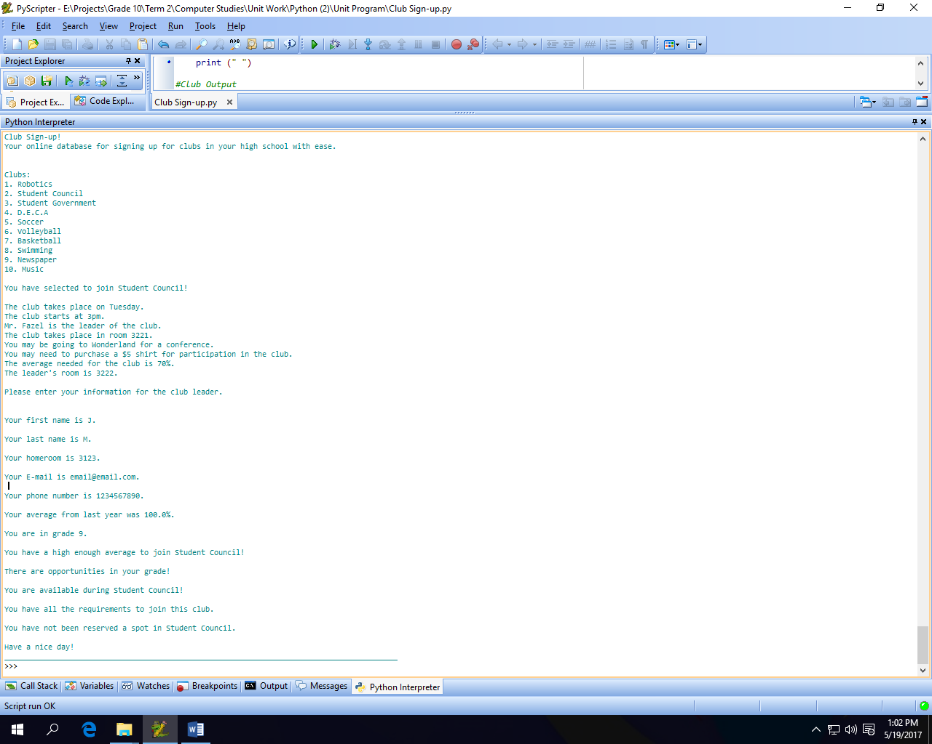

**Results:** Since the program didn’t crash and told the user whether they were eligible for the club they selected or not and gave them an option to retry, the program **passed** this test.

**Test #3**

**Input:**

* Club = 3.
* Average = 20
* ~~Available =~~
* Grade = 10
* ~~Confirm Club =~~
* Apply = No

**Expected Output:**

I expect the program to output:

* You have selected to join Student Government!
* The club takes place on Wednesday.
* The club starts at 3pm.
* Mrs. Henry is the leader of the club.
* The club takes place in room 3221.
* You may be going to Wonderland for a conference.
* You may need to purchase a $5 shirt for participation in the club.
* The average needed for the club is 75%.
* The leader's room is 3221.
* Your average from last year was 20.0%.
* You are in grade 10.
* Your average is 55.0% too low to join this club.
* Have a nice day!

**Actual Output:**

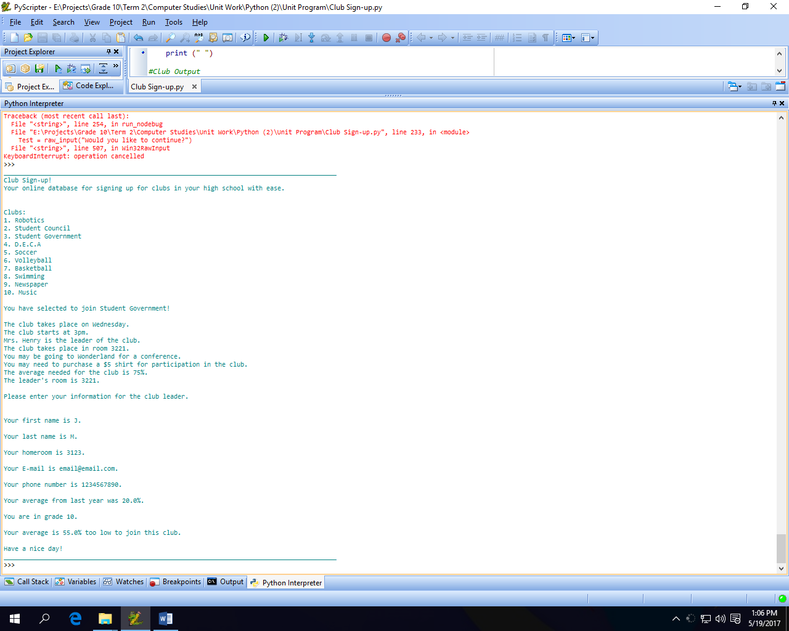

**Results:** Since the program didn’t crash and told the user whether they were eligible for the club they selected or not and gave them an option to retry, the program **passed** this test.

**Test #4**

**Input:**

* Club = 4.
* Average = 80
* Available = no
* Grade = 10
* ~~Confirm Club =~~
* Apply = No

**Expected Output:**

I expect the program to output:

* You have selected to join D.E.C.A!
* The club takes place on Thursday.
* The club starts at 3pm.
* Mrs. Woods is the leader of the club.
* The club takes place in room 3204.
* You may be going to a D.E.C.A. meet in Toronto.
* You may need to purchase a $5 shirt for participation in the club.
* The average needed for the club is 80%.
* The leader's room is 3204.
* Your average from last year was 80.0%.
* You are in grade 10.
* You have a high enough average to join D.E.C.A!
* Sorry, there are no opportunities in your grade.
* Have a nice day!

**Actual Output:**

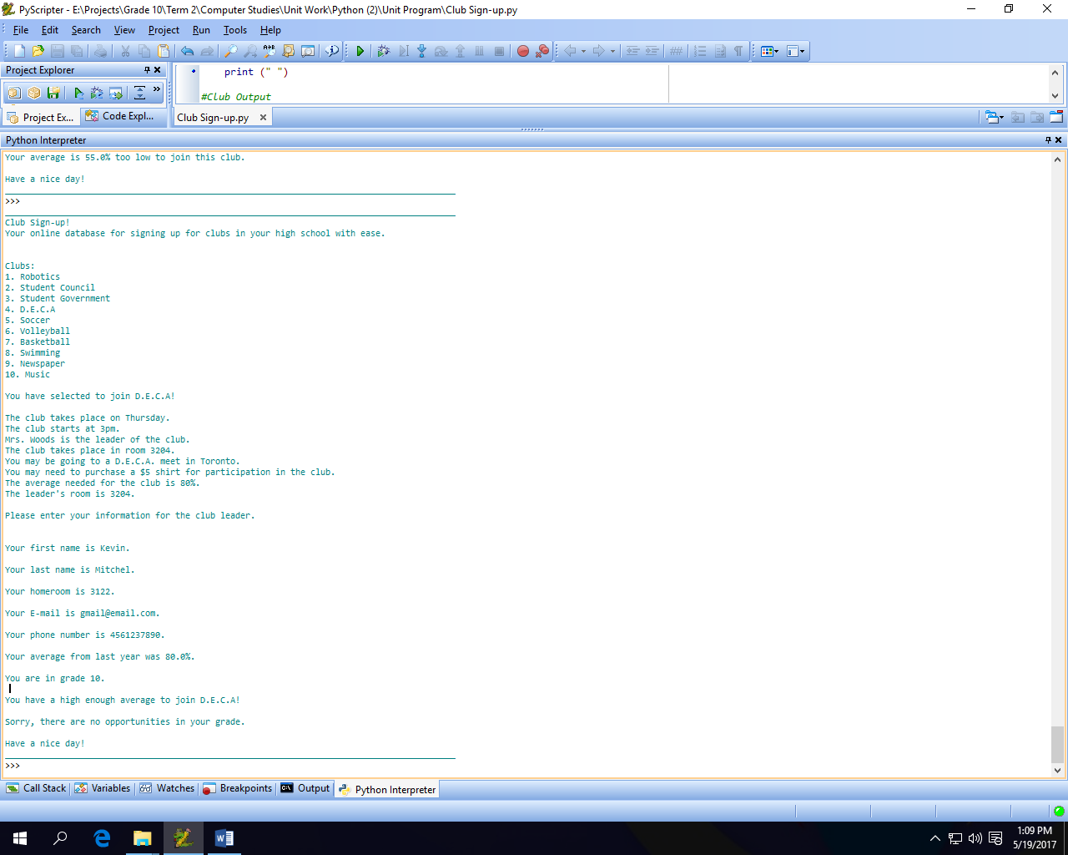

**Results:** Since the program didn’t crash and told the user whether they were eligible for the club they selected or not and gave them an option to retry, the program **passed** this test.

**Test #5**

**Input:**

* Club = Soccer
* Average = 65
* Available = yes
* Grade = 11
* Confirm Club = yes
* Apply = yes

**Expected Output:**

I expect the program to output:

* You have selected to join Soccer team!
* The club takes place on Tuesday and Thursday.
* The club starts at 7am.
* Mr. Chapman is the leader of the club.
* The club takes place in Gym B.
* You may be going to various schools to compete against others.
* You may need to purchase a jersey for $10 for participation in the club.
* The average needed for the club is 65%.
* The leader's room is 3108.
* Your average from last year was 65.0%.
* You are in grade 11.
* You have a high enough average to join Soccer!
* There are opportunities in your grade!
* You are available during Soccer!
* You have all the requirements to join this club.
* You have been reserved a spot in Soccer!

Saying “yes” to apply just re-runs the program.

I closed my program therefore it outputted, “Have a good day.!”

**Actual Output:**

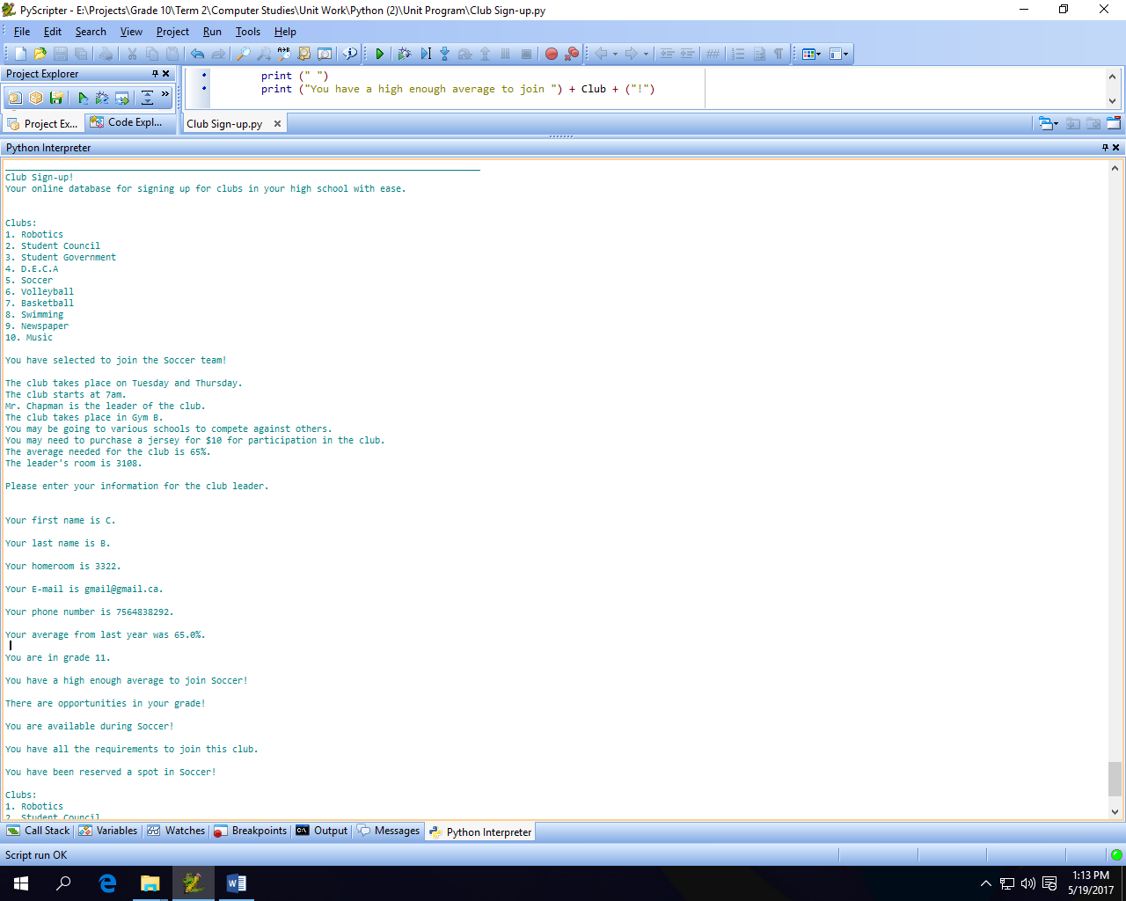

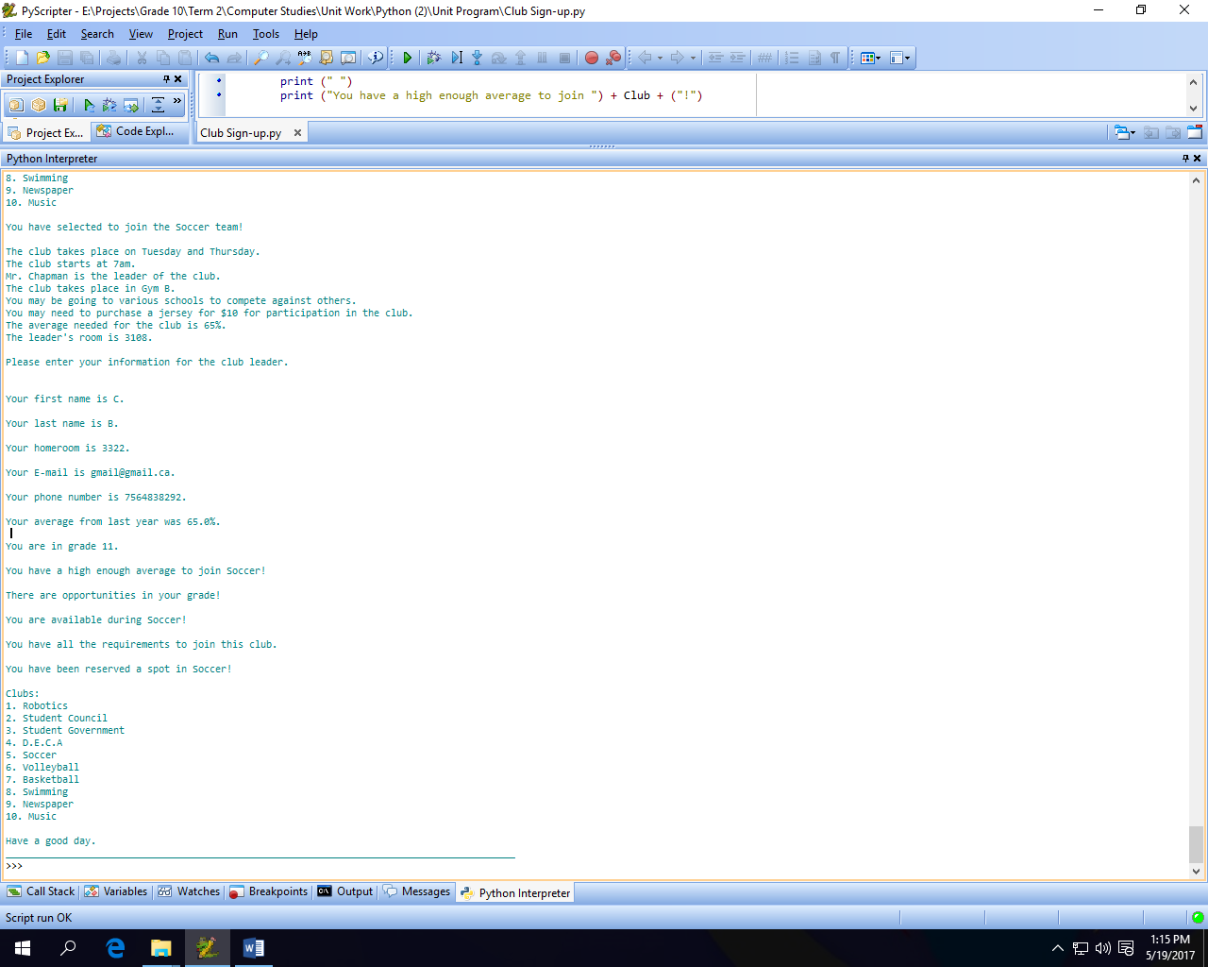

**Results:** Since the program didn’t crash and told the user whether they were eligible for the club they selected or not and gave them an option to retry, the program **passed** this test.

**Test #6**

**Input:**

* Club = Volleyball
* Average = 45
* ~~Available =~~
* Grade = 12
* ~~Confirm Club =~~
* Apply = no

**Expected Output:**

I expect the program to output:

* You have selected to join Volleyball team!
* The club takes place on Monday and Wednesday.
* The club starts at 7am.
* Mrs. Radice is the leader of the club.
* The club takes place in Gym B.
* You may be going to various schools to compete against others.
* You may need to purchase a jersey for $10 for participation in the club.
* The average needed for the club is 65%.
* The leader's room is 3206.
* Your average from last year was 45.0%.
* You are in grade 12.
* Your average is 20.0% too low to join this club.
* Have a nice day!

**Actual Output:**

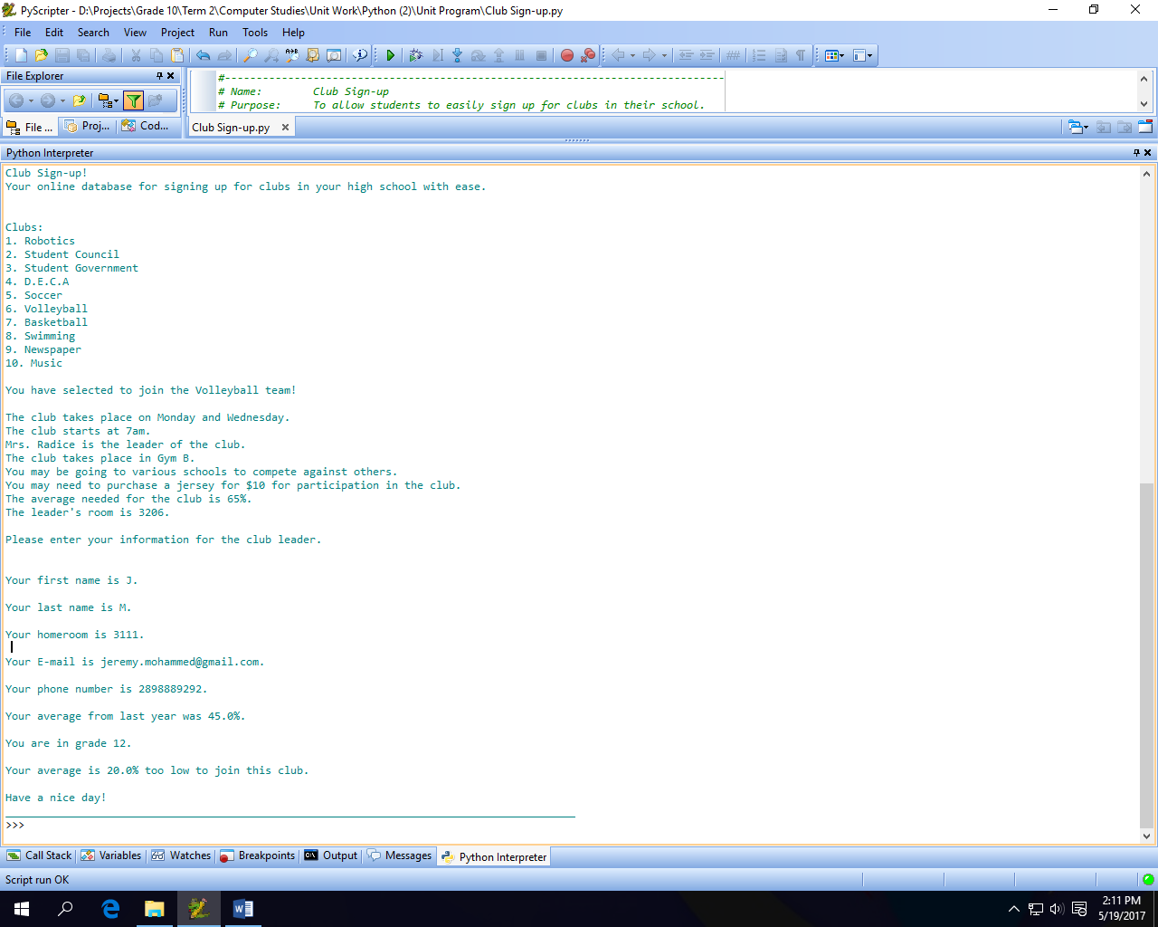

**Results:** Since the program didn’t crash and told the user whether they were eligible for the club they selected or not and gave them an option to retry, the program **passed** this test.

**Test #7**

**Input:**

* Club = basketball
* Average = 95
* Available = no
* Grade = 9
* ~~Confirm Club =~~
* Apply = no

**Expected Output:**

I expect the program to output:

* You have selected to join Basketball team!
* The club takes place on Tuesday and Friday.
* The club starts at 7am.
* Mr. Geett is the leader of the club.
* The club takes place in Gym B.
* You may be going to various schools to compete against others.
* You may need to purchase a jersey for $10 for participation in the club.
* The average needed for the club is 65%.
* The leader's room is 3228.
* Your average from last year was 95.0%.
* You are in grade 9.
* You have a high enough average to join Basketball!
* There are opportunities in your grade!
* Sorry you are not available for Basketball.
* Have a nice day!

**Actual Output:**

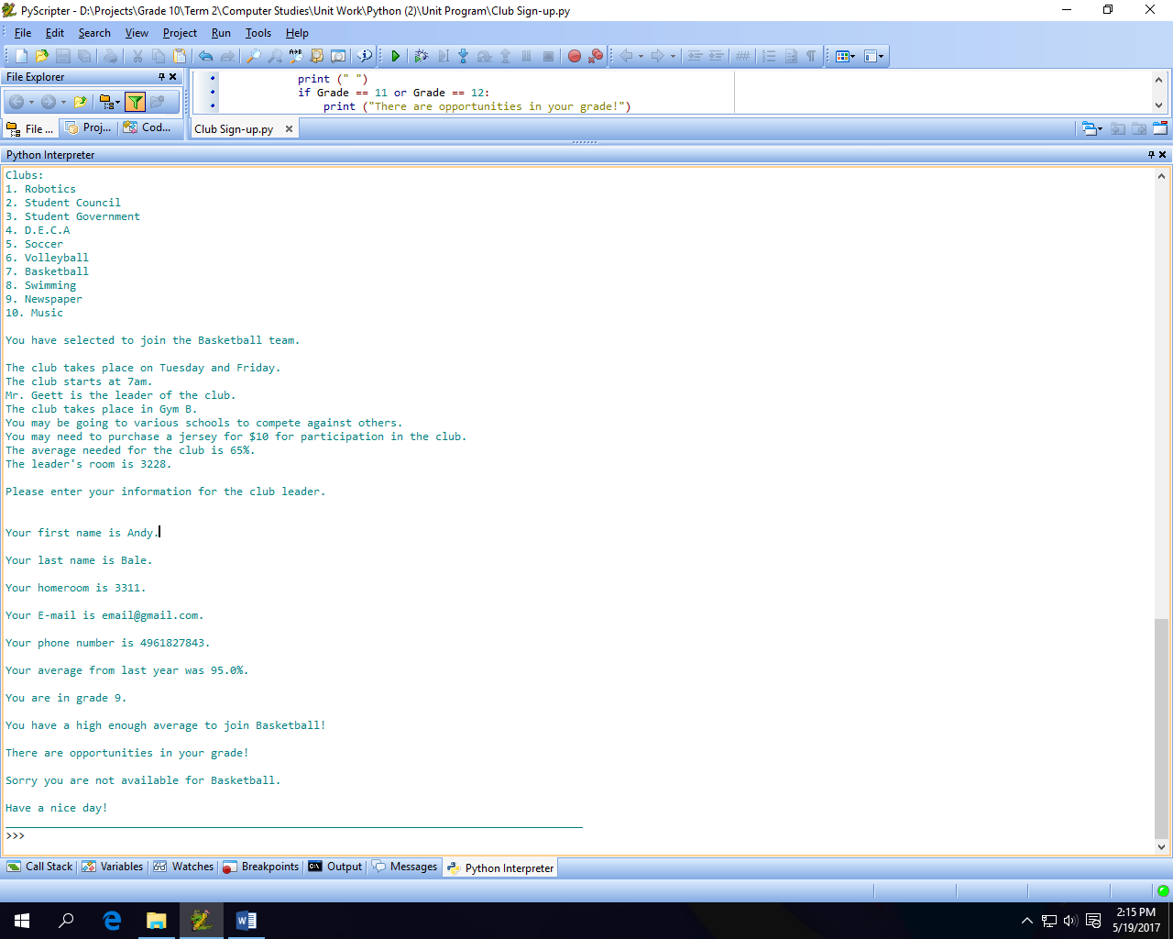

**Results:** Since the program didn’t crash and told the user whether they were eligible for the club they selected or not and gave them an option to retry, the program **passed** this test.

**Test #8**

**Input:**

* Club = swimming
* Average = 67.8
* Available = yes
* Grade = 9
* ~~Confirm Club =~~
* Apply = No

**Expected Output:**

I expect the program to output:

* You have selected to join Swimming team!
* The club takes place on Monday and Thursday.
* The club starts at 7am.
* Mrs. Sessa is the leader of the club.
* The club takes place in Gym A.
* You may be going to recreational centres for practices and meets.
* You may need to purchase a $20 swimsuit for participation in the club.
* The average needed for the club is 65%.
* The leader's room is 3132.
* Your average from last year was 67.8%.
* You are in grade 9.
* You have a high enough average to join Swimming!
* Sorry, there are no opportunities in your grade.
* Have a nice day!

**Actual Output:**

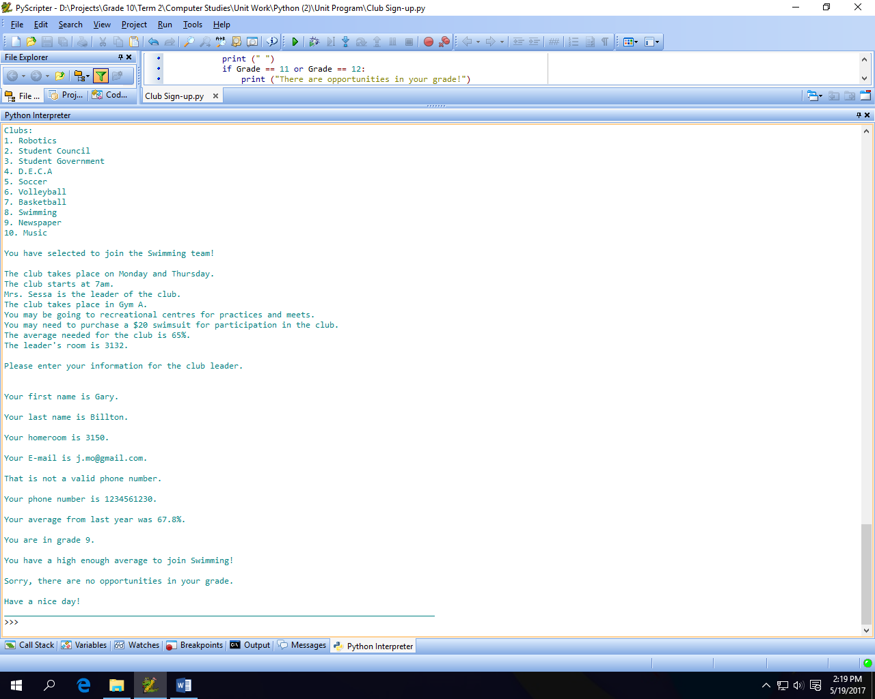

**Results:** Since the program didn’t crash and told the user whether they were eligible for the club they selected or not and gave them an option to retry, the program **passed** this test.

**Test #9**

**Input:**

* Club = 9
* Average = 92.7
* Available = yes
* Grade = 11
* Confirm Club = yes
* Apply = no

**Expected Output:**

I expect the program to output:

* You have selected to join Newspaper club!
* The club takes place on Wednesday.
* The club takes place during lunch.
* Mrs. Wells is the leader of the club.
* The club takes place in room 3105.
* You may need to purchase a $5 shirt for participation in the club.
* The average needed for the club is 75%
* The leader's room is 3105.
* Your average from last year was 92.7%.
* You are in grade 11.
* You have a high enough average to join Newspaper!
* There are opportunities in your grade!
* You are available during Newspaper!
* You have all the requirements to join this club.
* You have been reserved a spot in Newspaper!
* Have a nice day!

**Actual Output:**

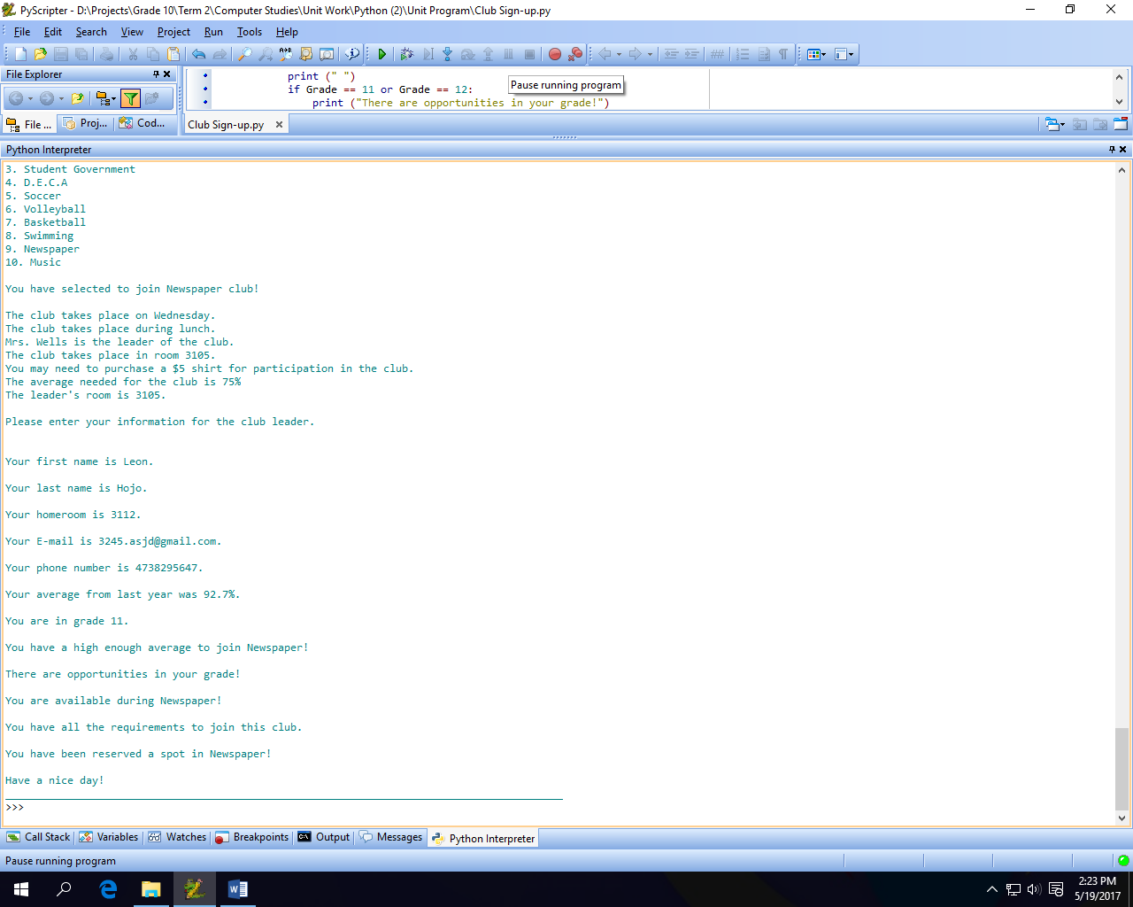

**Results:** Since the program didn’t crash and told the user whether they were eligible for the club they selected or not and gave them an option to retry, the program **passed** this test.

**Test #10**

**Input:**

* Club = Music
* Average = 90
* Available = yes
* Grade = 11
* Confirm Club = Yes
* Apply = no

**Expected Output:**

I expect the program to output:

* You have selected to join Music club!
* The club takes place on Friday.
* The club starts at 3pm.
* Mrs. Fletcher is the leader of the club.
* The club takes place in room 3157.
* You may be going to various schools to perform.
* You may need to purchase a $5 shirt for participation in the club.
* The average needed for the club is 70%.
* The leader's room is 3157.
* Your average from last year was 90%.
* You are in grade 11.
* You have a high enough average to join Music!
* There are opportunities in your grade!
* You are available during Music!
* You have all the requirements to join this club.
* You have been reserved a spot in Music!
* Have a nice day!

**Actual Output:**

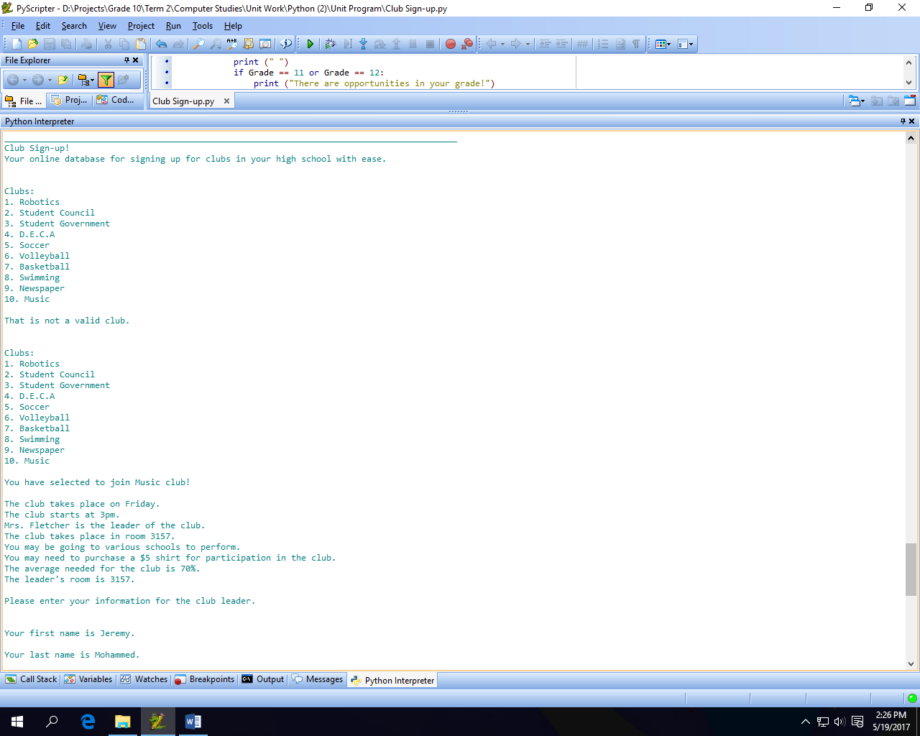

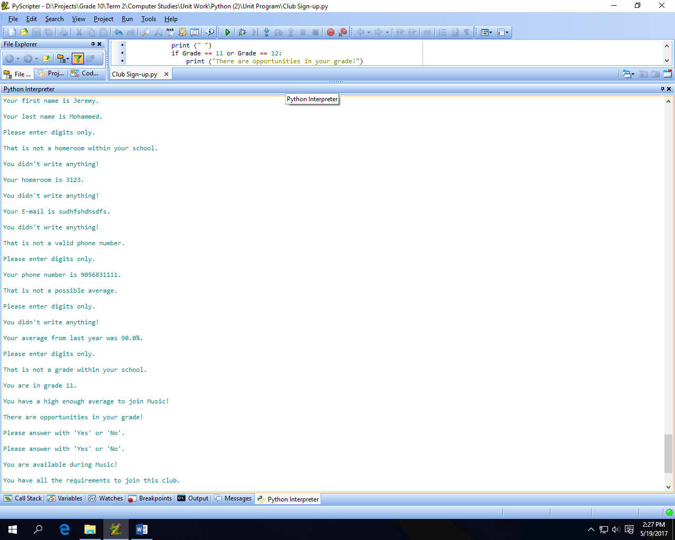

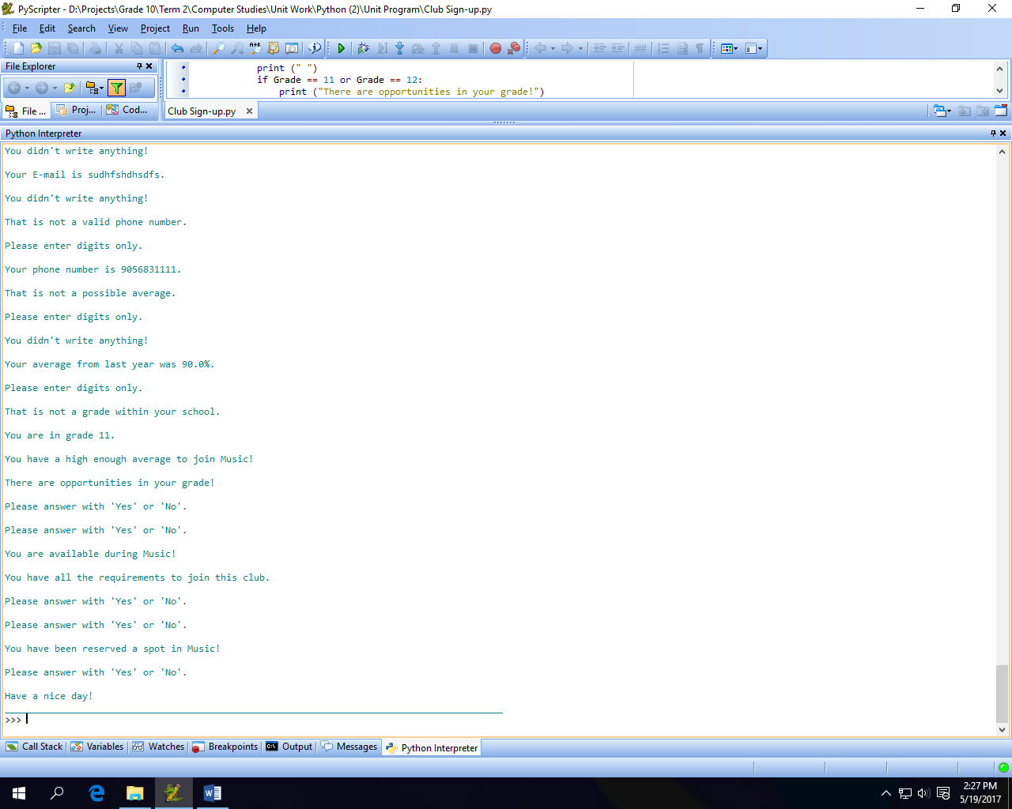

**Results:** Since the program didn’t crash and told the user whether they were eligible for the club they selected or not and gave them an option to retry, the program **passed** this test. This test I inputted many different invalied inputs for every question like no text, random characters, and numbers that may have not match to the specified like homeroom or grade. The program did not crash and looped everything that was invalid.